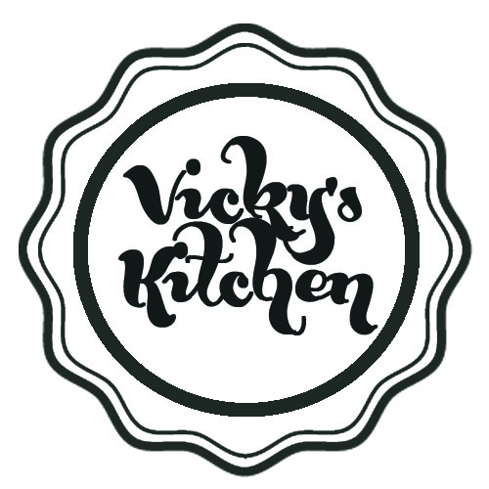

Buffet Menu

£6.50 per head
Sandwiches:
Cheese and pickle (v)
Falafal, cos lettuce, cucumber and chipotle mayo. (v)
Ham, tomato, lettuce, Dijon mayo
Egg mayo and salad
Tortilla chips with homemade salsa, guacamole and sour cream
Skinny fries with BBQ sauce, tomato sauce and mayo
Mixed salad (tomato, cucumber, red onion, spring onion)
Baked Vanilla Cheesecake

Then add 1 for £1.50, 3 for £4 or 6 for £7.50 per head from:
Handmade sausage rolls
Southern fried chicken strips
Bacon and egg tartlets
Honey and chorizo glazed chicken wings
Mini fish and chip cones
Crayfish popcorn
Crab and apple choux fritters

We can also do a range of hot food for your event including pizzas and burgers which are available from £8 per head.

